

LAND VALUE TAX AND SOCIAL JUSTICE
In the last quarter century Britain has seen an unprecedented transfer of wealth towards the most affluent. The key indicator of inequality, the Gini coefficient, rose remorselessly under New Labour just as it had risen under the Thatcher government. More recently the tax and benefits measures introduced by the coalition have been savaged as being socially regressive.
Can the tax system be progressive? The answer is yes, but Land Value Tax (LVT) must be part of the solution. Without a significant element of tax on property holdings, tax is structurally regressive.
In Britain income is unevenly distributed. Take a representative sample of 100 people, and sort them into a procession from lowest paid to highest. You will find that the five lowest paid each earn only about £100 per week. The next five would each be on about £150 a week. The wage would rise quite slowly as you moved along the procession, so people near the middle of the procession– the 50’th person and the few afterwards- would be earning on average just over £400 a week. After this incomes would increase faster, and the fortunate five or so people at the end of the procession would be earning a very comfortable £1200 per week.
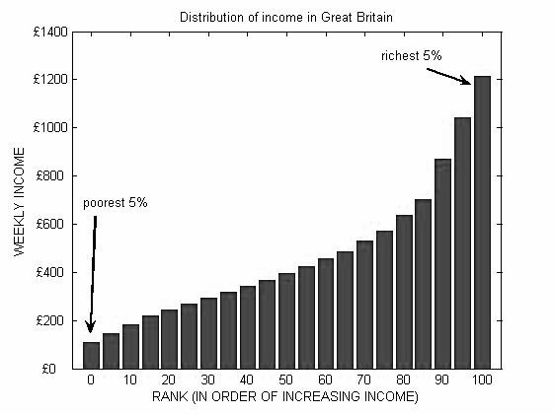
This procession is illustrated in the bar chart below. The population of Great Britain has been divided into “5-percentiles” , from lowest earners to highest earners, and the bar chart shows the average income received by each percentile. The figure for each percentile is averaged over the individuals in that percentile: in particular, a few individuals in the top 5-percentile receive considerably more than £1200 – for example, professional footballers or bankers- but this is made up for by the many individuals who receive rather less.
This gives rise to the idea that income tax seems is the fairest way of raising money. Unfortunately there is a problem, especially in Britain. While income is distributed unevenly, ownership of wealth (such as property and financial assets) is distributed even more unevenly. This is shown in the bar chart below, which shows the distribution of property wealth, again divided into 5-percentile segments of the population. While the distribution of income shown in the figure above is certainly uneven, it is nothing like as skewed as the ownership of wealth
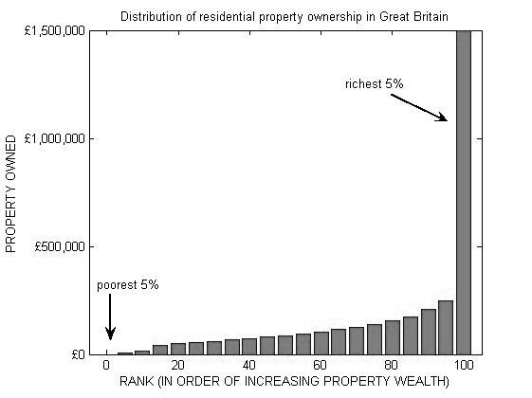
In fact, if you made a procession of 100 people in order of property wealth the richest 5 would own almost half the total. They would be on average 6 times wealthier than the next 5 persons in the procession- themselves relatively affluent individuals- and 15 times as wealthy as persons in the middle of the procession. And property tends to mean land: half of all UK wealth is privately owned residential property.
In the “income” procession, the 5 persons with the highest income get about 20% more income than the next 5 highest, so they pay rather over 20% more tax. But due to the distribution of property, they are 600% wealthier.
When tax is based exclusively on income, individuals who are just outside the wealthy elite will compare themselves with others who are many times wealthier and see that the amount of tax they pay is not very different. The more unequal the distribution of wealth, the worse this group is affected since the tax system erodes their limited wealth at a disproportionate rate. However the evils of gross inequality, so tellingly documented in the book “The Spirit Level” by Wilkinson and Pickett, affect all. Unless politicians find the courage to tax wealth, not just income, gross inequality will continue to afflict British society.
Social inequality arises as legitimate consequence of economic activity; some people are more talented, work harder, or are simply luckier in their enterprise than others. It is in the interests of society to reward wealth creating behaviour. However, there is no justification at all for a tax system that promotes inequality, as happens in the UK. The failure of the Labour part to tackle this during their long term in office shows deep moral bankruptcy. In government the Liberal Democrats must do better.
Taxes on wealth in the form of land and buildings must be part of a fair system, operating along with income tax. Property ownership is an excellent indicator of overall wealth, and is easy to identify: land cannot be moved or taken offshore, unlike financial assets. Any property tax needs to be well implemented, and other leaflets in this series explain the economic benefits of LVT.
There is a popular belief that income tax is the fairest tax, since it reflects ability to pay. This is wrong. Income tax is easy to extract, and for the very wealthy is relatively painless: but it does not truly reflect ability to pay. LVT must be part of a progressive tax system. With a tax system based on income, middle income earners will continue to complain bitterly that their taxes are too high. They will be right, but the real pain will be endured by the poor.
Liberal Democrat
Action for Land Taxation and Economic Reform
Author: David Cooper
Contact us at info@libdemsalter.org.uk
One of a series of LVT information sheets, editor D Cooper ©ALTER MMX
Printed and published by P. Elderton, 86 Rothes Road Dorking, Surrey RH4 1LB

source: Institute for Fiscal Studies: Report “Inequality and Poverty”
source: HM revenue and customs Estimated wealth of individuals in the U.K., 2003 (year of death basis)

