
LVT Wildlife & The Environment
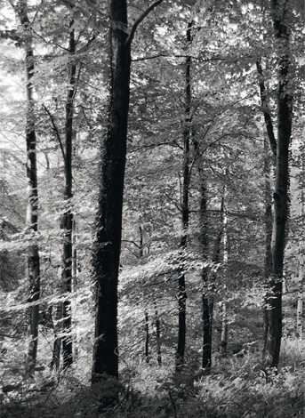
Land Value Tax (LVT) on all land in the UK will not only create jobs and boost the economy, but is the key to protecting our wildlife and conservation of natural resources.
LVT will allow all the citizens of the United Kingdom to share in the natural riches of our country and feel that they have a stake in its future. This will have many benefits for community cohesion and respect for the countryside and private property.
LVT has been recognised as the key economic reform by the academic discipline of ‘Environmental Economics’ as the only policy that will allow us to square the circle of having a growing economy, increasing employment with greater wildlife protection and conservation of natural resources.
Natural Capital
Government revenue should come from Natural Capital; the free gifts that nature gives us: the natural fertility of the soil, the sun, the water and the resources of oil and minerals. At present our tax system allows the monopoly value of these resources to be privatized without tax. This has the long term effect of concentrating unearned income into the hands of a few and reducing economic efficiency.
As society develops and becomes wealthier so natural capital, as a finite limiting resource, comes to constitute an ever increasing proportion of total wealth. But its monopoly value also concentrates in fewer hands, in the guise of corporate landowners and unproductive financial speculators. They capture ‘economic rent’ and make huge capital gains, acting as a massive drain on entrepreneurship and the productive members of our society.
Direct taxation of a fixed resource such as natural capital will have far less impact on our economy than taxation of trade and wages. This will allow jobs and industry to flourish while at the same time acting as a constant force to conserve the use of land and natural resources. The practical effect of this is that we will use our existing developed land far more efficiently; investment capital will flow to poorer areas and derelict land instead of seeking out green fields to exploit. Business and individuals will have a great incentive to conserve oil and minerals stimulating new green industries.
Giving Value to Wildlife
The fundamental problem we have in nature conservation is that when wildlife is destroyed there is no sanction. LVT will provide a positive feedback loop giving cash cost to wildlife destruction for anyone seeking to use natural land or intensify its use as this will have an impact on its unimproved value. Whenever a natural place is destroyed so it’s ‘Land Value’ will increase and thus it will be taxed accordingly.
Conversely marginal land that is of little commercial economic value (that is held in covenant as such) will have no commercial value and be free from such a tax – thus landowners will be encouraged not to use land in uneconomic ways that destroy wildlife promoting the creation of many more areas of high wildlife value that will have little impact on the productive economy.
Creating economically competitive rural, farming and conservation employment
Our present system of taxation vastly favours tax-dodgers, land speculators, large landowners and investment in huge capital infrastructure. This promotes the use of ever more intensive agricultural systems, increasing animal suffering, oil based chemical use and disproportionately drives jobs out of rural areas.
Huge tax breaks exist for the purchase of large machines and capital infrastructure. Fuel, fertilisers and agricultural chemicals all have huge subsidies and do not reflect their true cost to society or the environment.
Taxation removed from wages and trade allows the creation of rural and urban jobs. In rural areas this would be further enhanced as it would allow less intensive systems of agriculture, that coexist with native wildlife, to become economically competitive, when compared with our most damaging forms of industrial agriculture. Opportunities would arise in our leisure and wildlife conservation businesses offering benefits for the rural economy in recreation and tourism.
Intensive livestock farming inputs like palm oil husks and soya, which are grown at the expensive of tropical rainforest, would also become less economically competitive, helping to save areas of high biodiversity elsewhere on our planet.
Why other systems have failed
There has been a series of attempts by government to enhance wildlife and protect our natural resources at a huge cost to the taxpayer. Many of these efforts have meant little benefit for wildlife yet have increased the land prices and enriched only a few landowners
Grants to landowners, agricultural subsidies and land use policy have been a disaster for British wildlife.
Just like the disaster of housing policy over the last 30 years, so we have created a system whereby the taxpayer ‘rents’ wildlife from private landlords. This is hugely costly and a massively inefficient way of protecting wildlife. A general LVT will achieve a much greater level of wildlife protection with a much reduced cost to the taxpayer and reduce the need for DEFRA to administer and police current grant systems.

The greatest Liberal politicians of the last 100 years have supported LVT as the key economic reform that will bring economic growth, employment, balance of payments, social cohesion & crime reduction. The new academic movement of ‘Environmental Economics’ has now recognised LVT as key to the protection of our wildlife and conservation of the natural resources of the planet.
Liberal Democrat
Action for Land Taxation and Economic Reform
Author: Peter Smith, Chief Executive, Wildwood Trust
Contact us at info@libdemsalter.org.uk
One of ALTER’s series of LVT fact sheets, editor D Cooper ©ALTER MMXI.
Printed and published by P. Elderton, 86 Rothes Road Dorking, Surrey RH4 1LB

