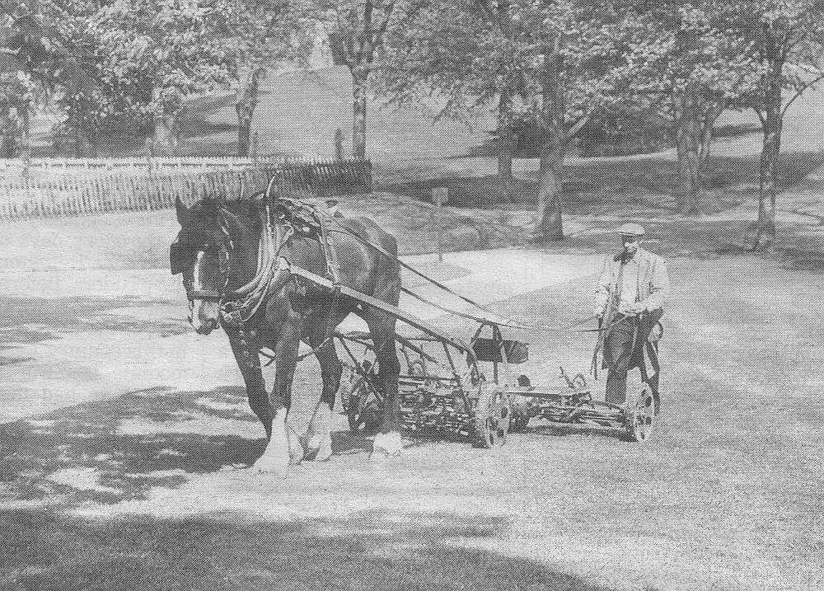

AGRICULTURE & LAND VALUE TAXATION
The moral argument for LVT is that land value is created by the efforts of the community at large and not the land holder. Land values rise where settlements are created, power supplies developed or communication links laid. For agriculture, land value is also a reflection of natural advantages such as favourable climate, topography and soils, which, again, no land holder can claim to have created. LVT regards land value as a public resource and thus the natural fund out of which public expenditure should be drawn
Under LVT, farms would be charged according to the value of their land, excluding the value of any improvements (drainage, buildings etc). Crucially, the poorest land in use would not be taxed because it benefits least from communally-created infrastructure or natural advantages. Hence LVT charges would range from zero for the remotest and most marginal upland grazing, to higher assessments for, say, intensive market gardening land close to a large city.
Without LVT, public revenue must come instead from taxation of personal earnings [PAYE & NI] and corporate profit. In short, taxation of human effort and skill replaces taxation of space and natural advantages. This distorts farming and the rural economy in three ways. (i) Farm labour is replaced by capital-intensive methods, causing rural depopulation. (ii). Farmland becomes increasingly regarded as a speculative investment. (iii). Marginal land is driven out of production. All have far-reaching and damaging consequences.
(i). Rural depopulation
Present taxes are such that, to pay two employees, a farmer must pay HMRC approximately the take-home pay of a third man, but if he compensates for this by mechanising to raise the efficiency of his workforce, he receives tax relief on the capital outlay.
Hence farms have steadily replaced labour with capital equipment and technology - combine harvesters, chemical fertilizers, pesticides, genetically modified crops, factory farming of animals – all intended to raise average output per employee. To make economies of scale, farming is now dominated by relatively few highly capitalised agribusiness companies, owning many farms and thousands of acres, leaving few opportunities for new individual farming entrepreneurs.
Though seemingly efficient internally, these corporations create significant diseconomies for the community at large. The loss of farm employment, with its related loss of demand for rural shops, transport, schools and healthcare, aggravates the drift of population to already over-congested conurbations. It reduces the amount of physical work available for the less technically qualified, and cuts people off from nature.
Animal husbandry, being more labour intensive, has suffered. Traditional ‘mixed farming’, where arable fields were rotated with stock grazing and fertilised organically, has been replaced by specialised crop farms relying on chemical substitutes. It also means that while good pastoral land at home lies idle, we import meat from the developing world, which increases food miles, encourages the clearing of rain forests for stock rearing, and raises prices in the exporter countries above what many local people can afford.
(ii). Increased speculative value of farmland.
The other destructive effect of failing to extract LVT from land holders is that it encourages the buying of rural land for investment as much as for farming. This is especially evident in the rural-urban fringes where pressure for urban development and periodic releases of Green Belt land make speculative gains most likely. Because investment land can also serve as collateral for loans to make further land purchases, farm owners often maximise their holdings without necessarily using them to the full. All of this forces land prices above that justified by a normal farm income, putting it beyond the reach of many new entrants to farming.
As mentioned earlier, taxing of earnings and profits raises labour costs. This makes our farming likely to be undercut by cheap food imports from low wage economies in the less-developed world, causing it to rely on subsidies. These payments are usually based on the area of land a farmer has available (not necessarily in use) for farming. This again encourages farmers to hold more land than they really need, simply to obtain the support payments, so aggravating the shortage of land for new entrants already mentioned. Moreover, the whole system of farm support hinders economic growth in developing countries by making it harder for their farmers to compete in our markets.
(iii). Loss of marginal land
Taxing work drives marginal land out of production because it usually needs more effort per unit of production than better land. This explains much of the struggle to make farming pay in remote uplands, and the general under-use of land seen in all but the most favourable areas – both of which reduce opportunities for young farmers, and encourage calls for market-distorting subsidies.
Conclusion
Shifting the national tax base away from personal earnings and corporate profit and towards LVT would resolve these conflicts. It would redress the economic balance between labour and machinery in farming and allow more people to be employed, helping to relieve overcrowded cities and revive marginal areas. With LVT in place few would hold more land than they could effectively use, because the LVT payable would assume that the land was put to its best permitted use. This would also discourage speculative land holding since any increase in its value would merely result in higher LVT. Speculatively held land on urban fringes would be released for new entrants to farming, and since such land near urban markets tends to be used more intensively than land further out, many new jobs would become available just where they are currently most needed.
Liberal Democrat Action for Land Taxation and Economic Reform
Author: John Howell
Contact us at info@libdemsalter.org.uk
One of a series of LVT information sheets, editor D Cooper
Printed and published by P. Elderton, 86 Rothes Road Dorking, Surrey RH4 1LB
© ALTER MMXII

